Building Your
Grants Monitoring Program
Key Questions to Consider

Table of Contents

Who Will Be Monitored? 2
What Standards Will Be Monitored? 2
What About Best Practices? 3
When Should Monitoring Begin? 3
How Quantitative Should You Be? 4
Fiscal Monitoring, Programmatic Monitoring, or Both? 4
Who Will Do the Monitoring? 4
How Will Monitors Be Trained? 5
What Size Should the Budget Be? 5
What About Scheduling Protocols? 5
Can You Consolidate Monitoring Efforts? 6
What Are the Systemic Weaknesses? 6
What About Technical Assistance? 6
What If You Find Something Serious? 6

Key Questions

Who Will be Monitored?
ESSA specifies that certain funded programs must be monitored, but beyond that, it gives latitude on how funds are monitored and how often each school program is to be monitored. There is a caveat: the Secretary of the U.S. Department of Education, in conjunction with the Inspector General, is required to develop guidance on how monitoring is to be undertaken - and that guidance is expected to provide more specifics. But for now, leeway exists.
When the number of schools or programs is large, monitoring every school every year becomes impractical. So districts and states typically divide the total number of schools by the number of years in the monitoring program, and monitor the same number of schools each year.
Schools and programs can be selected randomly on a cycle-based rotation or based on risk. The latter is the required approach for title programs, according to updated Uniform Grant Guidance. In a risk-based approach (depending on the program), criteria for prioritizing a school could include low or declining achievement test scores, significant findings in audits or past monitoring reviews, failure to meet important deadlines, failure to respond to important requests for information such as completion of fiscal self-assessments, complaints, slow expenditure or misspending of funds, overspending of funds, application quality, and indicators ranging from high student dropout rates and safety incidents to high staff absenteeism and leadership turnover.

What Standards Will Be Monitored?
Outside of specific mandates, the myriad of federal requirements in ESSA permits a state or school system creativity in designing a monitoring program, particularly in the area of educational programs.
Want to review how many times a school suspends children out of school? ESSA addresses that practice and, therefore, such a standard can be included in a monitoring tool.
Want to focus on how children transition from preschool to kindergarten? Or from high school to college? That can be monitored as well. Monitoring can address a wide range of activities, but they should begin with those specified in ESSA and in program initiatives contained in approved grant applications.

What About Best Practices?
Designers of monitoring programs should consider whether to measure only compliance with statutory and regulatory requirements or whether to also gauge implementation of best practices that are not mandated by law. The U.S. Department of Education has permitted flexibility in incorporating standards that drive educational best practices, because increased student achievement is the ultimate goal of ESSA. That permits schools to align standards to the strategic vision of the school system, using compliance monitoring as only one component in its realization.
​Effective program implementation begins by setting standards, followed by training on the standards, then implementing the standards, followed by testing their implementation, and retraining and retooling on the standards based on gaps identified during reviews.
Thus, the standards selected for monitoring can roll into a larger vision. However, it is important to distinguish in the monitoring report which standards are strictly measures of compliance and which are based only on effective practices. In the latter case, schools should not be held accountable or be required to create Corrective Action Plans for standards not mandated by law. The essential purpose of those reviews is to provide technical assistance.
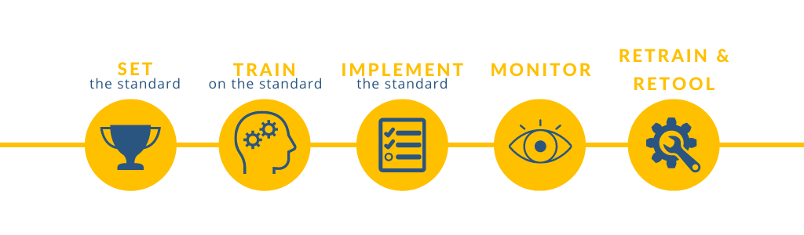
When Should Monitoring Begin?
Stakeholder buy-in to a monitoring program dramatically increases when the standards to be monitored are discussed, selected, and communicated well in advance of the monitoring visits. Planning ahead is a matter of fairness. It also enhances compliance, because it gives schools and program leaders time to implement the activities being measured. It also provides time for training, an important part of the program implementation continuum. Furthermore, since the monitoring standards reflect the system's priorities, setting them early moves the school or system closer to realization of its strategic vision as reflected in the school or district plan. Therefore, the ideal time to plan a monitoring program is after the spending plan - whether for school improvement or otherwise - has been approved and while implementation is underway.

How Quantitative Should You Be?
​Will your program be quantitative or qualitative - or both? A quantitative approach permits data visualization of trends in compliance, including strengths and weaknesses. Data can be graphically displayed in heat maps and charts. Quantitative check-the-box approaches are easier to implement because they do not require development of lengthy, individualized reports.
However, qualitative approaches are often more effective in changing behavior. They thoughtfully report challenges to educating students, tailor them to each school’s challenges, chronicle best practices and exemplary programs, and better address root causes of non-compliance or poor performance. Qualitative reports can be more principle-based. For example, in a fiscal review, a principled-based approach might gauge whether funds drove improved student achievement, whereas a rule-based approach asks whether a school complied with allowable uses of funds under the law.

Fiscal Monitoring, Programmatic Monitoring, or Both?
​ ​Because protecting taxpayer money from loss or abuse is a stated objective of ESSA, monitoring should include reviews of how program funds are spent. Not only can fiscal reviews include examinations of expenditures to ensure they are permitted under the law, but they can also document the components of a program's financial management system. But how to combine fiscal reviews with monitoring of educational best practices – such as differentiation of instruction, library programs, or programs for English Language Learners – is a choice designers of the monitoring program make.​

Who Will Do the Monitoring?
​Related to budget is who will conduct the compliance reviews. Naturally, monitors should be detail oriented, accurate, knowledgeable on school operations, and well trained to provide technical assistance when gaps are found during monitoring visits. But monitors should also be independent. Line officers held responsible for performance of a pool of schools or individuals developing the programs to be monitored may be challenged in providing objective, independent reports. Why? Because honestly describing school challenges may reflect negatively on their performance. Although unrealistically positive reviews make an organization look good on the surface, they do little to improve education. The selected monitoring team should also have ample time to conduct the reviews or they will not be completed.

How Will Monitors Be Trained?
​ ​How will monitors be trained to ensure reports are standardized and reviews are completed with consistency, accuracy, and thoroughness?
Tools can include pre-visit training, electronic monitoring tools, knowledge management sites, and collaboration software to address frequently asked questions, re-emphasize training points based on weaknesses identified on school visits or in reports, and a library of the original sources of all standards. These include statutes, regulations, Executive Orders and Guidance, state policies, or effective practices being monitored.

What Size Should the Budget Be?
​Once an agency has determined what monitoring it should undertake, it must develop a budget. Factors to consider include the amount of time needed to design the program, the number of site visits, the number of days per a site visit, travel expenses, equipment needed, report-writing time, ​number of desk/document reviews, scope of technical assistance, and time needed to develop communication tools such as Intranets, software, and collaboration sites. Time to develop monthly status reports and monitor training should also be considered.
​The size of your monitoring program is based on both available funds and the importance of the monitoring program to the realization of state or systemic strategic goals. Logically, when there are challenges such as misspent funds or chronically low student achievement, monitoring budgets should rise. Likewise, the greater the number of schools or programs being monitored, the larger the monitoring budgets required.
​The level of existing oversight and the scope of responsibilities of those charged with oversight also plays a role. If schools rarely receive management visits, monitoring can fill an important gap in gaining critical information from the front lines to fuel strategies for improvement and technical assistance. ​

What About Scheduling Protocols?
Scheduling will run most smoothly by contacting each school in the monitoring plan for the year and mapping out breaks, holidays, Tribal celebrations (if applicable), administrative retreats, and testing times. Each is entered into a master schedule before visit dates are finalized.
Can You Consolidate Monitoring Efforts?
Should ESSA monitoring be combined with other types of educational monitoring? Some districts incorporate mandated monitoring for other statutes such as the Individuals with Disabilities Education Act. This requires a multi-disciplinary monitoring team but significantly reduces the burden on schools from multiple visits.​​

What About Systemic Weaknesses?
How will trends be identified? Ideally, monitors will have a mechanism to identify systemic weaknesses, ranging from backlogged software orders to delays in background investigations preventing the hiring of teachers.​

What About Technical Assistance?
​ESSA states that monitoring must include technical assistance. This reflects a "soft" approach to monitoring. Unlike compliance monitoring in more highly regulated industries, its aim is to enhance compliance in a non-punitive way. Providing technical assistance in monitoring is required by law, but how much and what type of technical assistance is left to the monitoring design team. ​

What If You Find Something Serious?
Monitoring programs should include escalation and resolution protocols in the rare instances when monitors encounter situations in which children are in danger or taxpayer funds are being improperly diverted. Missing in many monitoring programs is an "intensive review" function for areas requiring further and extensive investigation or consequences when something serious occurs.

